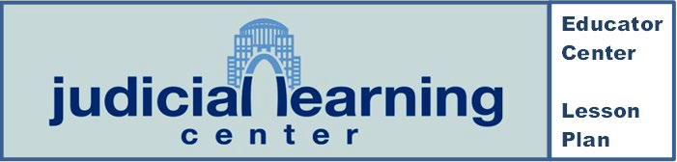

Do You Know Your Bill of Rights?
Lesson Plan: 4-5; 6-8

Overview
Students will use the Judicial Learning Center website to identify rights that are found in the Bill of Rights. They will use the answers to solve the puzzle in this activity.

Corresponding Student Center Pages
- The Constitution and Rights

Suggested Time Needed
1 class period

Learning Objectives
After completing this activity, students will:
- Have a greater understanding of the rights and liberties presented in the Bill of Rights.
- Be able to identify the rights granted in the Bill of Rights, by Amendment.

Guiding Questions
- Why is the Bill of Rights so important?
- How would the United States be different if we did not have the rights that are listed in the puzzle?

Missouri Grade Level and Course Level Expectations
- 4.PC.1.C - Explain the major purposes of the Bill of Rights. Identify important principles in the Bill of Rights.
- 5.PC.1.C - Apply the principles of the Bill of Right to historical time period being studied and to current events.
- 6-8.AH.3.GS.F – Describe the origins and purposes of the Bill of Rights and evaluate the enduring significance of these concepts to the preservation of individual rights and liberties.

Materials Needed

- Do You Know Your Bill of Rights? Puzzle
- B: Do You Know Your Bill of Rights? - Answer Key

Procedure:
- Place students into groups of 2, 3, or 4 depending on your class size and access to devices.
- Instruct students to navigate their internet browsers to the page they will use: https://judiciallearningcenter.org/the-constitution-and-rights/

- Distribute copies of A: Do You Know Your Bill of Rights?
- Allow time to complete.

- Conclusion. Go over the answers with the class. Ask these follow up questions:
  - Do some of the amendments in the Bill of Rights seem more important than the others? Which ones and why?
  - What are your 1st Amendment freedoms?

- Review the Guiding Questions
  - Why is the Bill of Rights so important?
  - How would the United States be different if we did not have the rights that are listed in the puzzle?

Do You Know Your Rights – Answer Key
1: Cruel or Unusual 2: Exercise
3: Civil
4: Incrimination
5: Impartial
6: Double
7: Indictment
8: Bail
9: Bear Arms
10: Freedom of Speech 11: Warrant
12: Petition
13: Search & Seizure 14: Due Process
Students will spell out the words: CIVIL LIBERTIES if they got all answer correct

